Derrygonnelly Primary School



Prospectus
2019/2020



DERRYGONNELLY PRIMARY SCHOOL PRIMARY
22 CALDRUM ROAD CONTROLLED
DERRYGONNELLY BOYS & GIRLS
BT93 6HY AGE RANGE 4-11

Tel. No - DERRYGONNELLY 028 68641286

CHAIRMAN OF GOVERNORS: Mr Richard Harkness
PRINCIPAL: Mr Blaine Stewart
NUMBERS ON ROLL (1 September 2019) 64
EXPECTED NUMBERS ON ROLL (1 September 2020) 68

ADMISSIONS NUMBER: 3 ENROLMENT NUMBER: 98

THE BOARD OF GOVERNORS
Nominated by the Transferors/Trustees

Mr John Ferguson
Mrs Rowena Hassard-Anderson

Nominated by the Western Education & Library Board

Mr Richard Harkness
Mr Geoffrey Cathcart

Elected by the Parents

Mrs Valerie Kernaghan
Mrs Norma Ferguson

Elected by the Teaching Staff

Mrs Naomi Hassard

Principal (Non-Voting)

Mr Blaine Stewart

TEACHING STAFF
September 2019

Principal Mr B. Stewart

P7 teacher Mrs A. Beddard

P6 teacher Mrs A. Beddard

P5 teacher Mr B. Stewart

P4 teacher Mr B. Stewart

P3 teacher Mrs N. Hassard

P2 teacher Mrs N. Hassard

P1 teacher Mrs N. Hassard

Principal release Mrs N. Morrison
teacher P6/7
(Mon/Fri)

Music Specialist Miss L. Geogh
(Violin)

ANCILLARY STAFF

School Secretary Mrs V. Fawcett

Caretaker Mrs R. Parke

Classroom Assistant Mrs J. Ferguson

Classroom Assistant Miss. D. Dunne

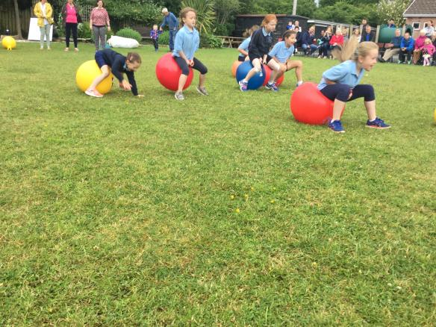
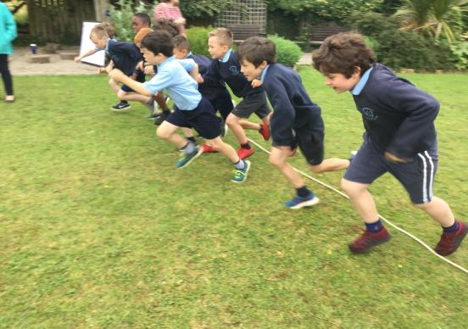
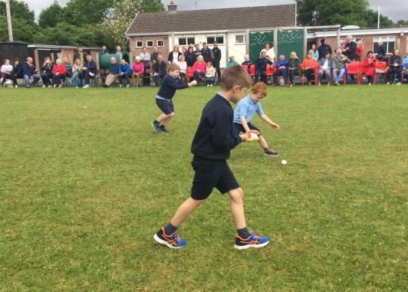
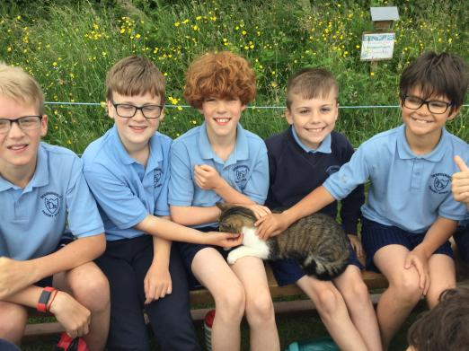
Sports Day fun 2018

GENERAL INFORMATION
Derrygonnelly Primary School is a Controlled School, owned and maintained by the Education Authority. It admits boys and girls aged from 4 to 11. It is set in its own grounds. The school seeks to promote a friendly, caring atmosphere and parents are always welcome to visit the school.
The school was founded in 1966 and has three spacious classrooms, toilets and cloakroom area. There is a dining hall which is used for physical education, music, assemblies, and other school functions.

SCHOOL HOURS
The school day begins at 9.20 am and children should be in their classrooms by this time. Children should not arrive at school before 8.45 am and no responsibility can be taken by the school for any children arriving on the premises before this time.
The lunch break is from 12.30 to 1.20pm.
All the children have a supervised playtime for 15 minutes in the middle of the morning.
The P1 and P2 classes finish their school day at 2 pm for the whole of the school year. School dinners cost £2.60 per day and the appropriate money should be sent on Monday morning. Menus are available to view and download from the school website and children may choose on a daily basis whether they wish to eat a school dinner or a packed lunch.
The P3 – P7 classes finish their school day at 3.15 pm although occasionally children may not leave until a few minutes afterwards, if there are clearing-up tasks to complete.

ATTENDANCE
All children should attend school for the 190 days which the law requires, unless they are ill. If children have to miss school for illness or any other reason, then parents should send into school a note explaining the absence for our records.

ADMISSION ARRANGEMENTS
The current policy is to admit children into the P1 class on the first day of the Autumn Term, those children who have reached compulsory school age, i.e., those children whose 4th birthday falls on or before 1st July 2019. Parents considering sending their children to this school are invited to make a prior visit, to see the school in action and to talk to the Principal and teachers. The admission arrangements as set out in the EA booklet on Primary Education will be used. Application forms are available from the school or EA offices.
ADMISSIONS CRITERIA
The Board of Governors will apply the following criteria, in the event of there being more applicants than places available, in the order set down.
E.g. Admissions to year 1.
- Children of compulsory school age who have brothers or sisters at the school.
- Children of compulsory school age regarded by the Board of Governors on the basis of written or other evidence supplied by the parents or other agencies as having special circumstances, i.e. medical, social or security reasons.
- Other children of compulsory school age.
- Children age 4 by 1st July in this year but who have not attained the lower limit of compulsory school age.
- Children from within a certain distance of the school.

VISITING ARRANGEMENTS FOR NEW PUPILS AND PARENTS
An Open Afternoon is held in our school, late in the autumn term. At this meeting, prospective pupils and their parents are shown around the school by the Principal and given any information requested.
During June, the new pupils are invited to come to school on two afternoons and left by their parents to spend time with their new teacher in their classroom.
This approach to introducing pupils to the school has been extremely successful and welcomed by parents.

PARENT- TEACHER MEETINGS
Formal meetings are arranged once a year for all parents. These usually take place in November.
In June, following the issue of written reports, there may be an additional meeting at the request of the teacher or parent.Parents are always welcome to come to school to discuss their child’s progress. We would, however, ask that parents contact school at given times i.e. not during school hours, to arrange an interview with the Principal or class teacher. We respectfully ask parents not to arrive at school for unarranged meetings.
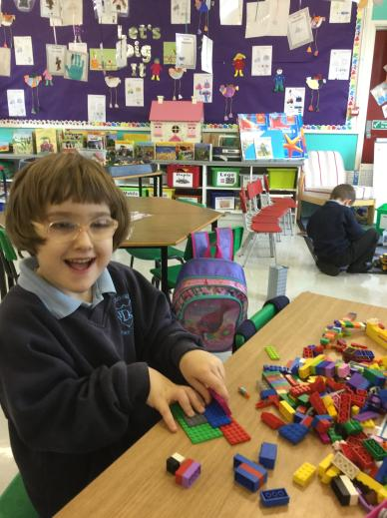

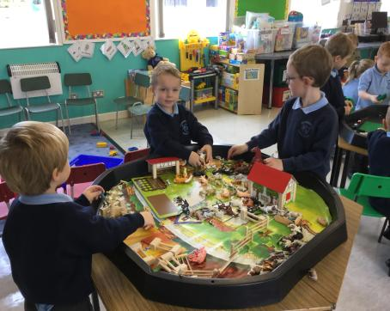

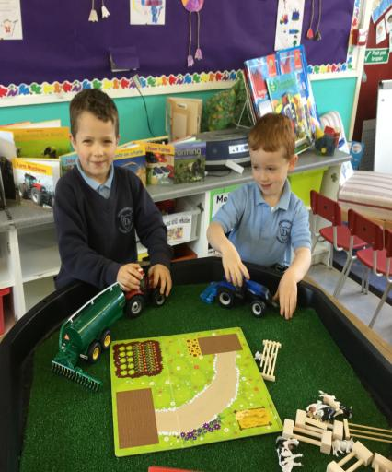
Play based learning at Foundation and Key Stage 1

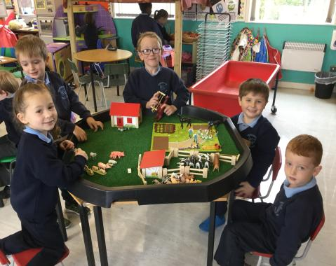

SECURITY MEASURES
For a number of years, we have operated a security system for parents or visitors calling at school. ALL VISITORS MUST REPORT TO THE FRONT DOOR OF THE SCHOOL AND RING THE BELL. (Parents can be assured that all tradesmen and deliverymen follow this procedure and all tradesmen are required to sign in when reporting to school and sign out when leaving. They are also required to wear identification badges when in school) No parent should be in the playground. When collecting children at lunchtime or after school, parents are asked to remain at the school gate.

CHILD PROTECTION
If parents have any concerns about the safety of their child (or another child) they should follow the procedure below
- Contact the class teacher
- If still concerned, contact our Designated Child Protection teacher (Mrs Beddard) or if unavailable one of our deputy Child Protection teacher (Mr Stewart or Mrs Hassard)
- If still concerned, contact the Chairperson of the Board of Governors (Mr Richard Harkness) or the Governor responsible for
Child Protection (Mrs Valerie Kernaghan)

GENERAL AIMS OF THE SCHOOL
- To recognise each child’s potential and provide opportunities to develop each individual to the highest level in the skills required within the NI curriculum.

2. To provide for each child a happy, stimulating and imaginative environment where success and satisfaction may be achieved.

3. To encourage children to become independent, self-motivated people yet at ease with their peer group and able to contribute to the society to which they belong.

4. To encourage children to develop attitudes and a sense of responsibility which will enable them to become valuable members of the community.

5. To develop an inquiring mind and an inquisitive attitude to learning.

6. To encourage the Christian and moral development of each child.
7. To encourage parental involvement to the extent of overseeing their children’s homework, both written and oral. Co-operation is desired when pupils are requested to contribute materials necessary for lessons.

8. We aim as a staff to attend courses which will assist us in the professional delivery of the Northern Ireland Curriculum.

CURRICULUM
The curriculum of the school is designed to give a broad and balanced education to all children and to present all children with experiences suitable to their current stages of development.

The curriculum is in a constant state of development; throughout the 2019-2020 academic year the staff will continue to implement the demands of the Northern Ireland Curriculum. The school is already providing worthwhile experiences in all the areas of study of the Northern Ireland Curriculum which are: -

- Language and Literacy (including Talking and Listening, Reading and Writing)
- Mathematics and Numeracy (focusing on the development of mathematical concepts and numeracy across the curriculum)
- The Arts (including Art and Design, Drama and Music)
- The World Around Us (focusing on the development of knowledge, skills and understanding in Geography, History and Science and Technology)
- Personal Development and Mutual Understanding (focusing on emotional development, social skills, learning to learn, health, relationships and sexuality education and mutual understanding in the local and global community)
- Physical Education (focusing on the development of knowledge, skills and understanding through play and a range of physical activities)

The school will be striving to present children with lively and exciting experiences, which will enable them to fulfil the Northern Ireland Curriculum requirements with enthusiasm and to attain the targets that are within their abilities. Pupil performance and development will be evaluated by appropriate assessment techniques and assessment will be reported to parents.

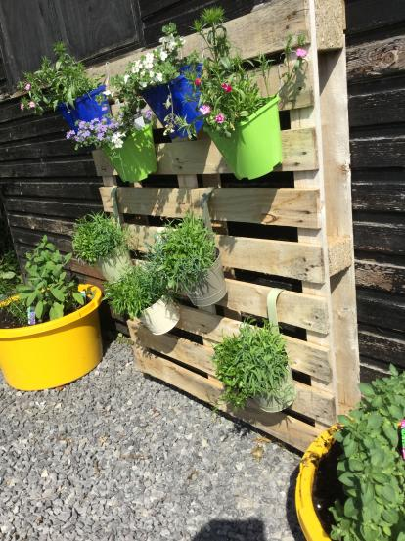
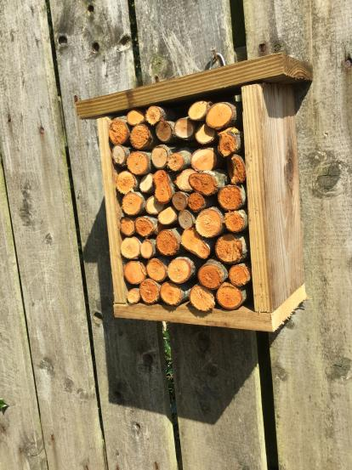
Pollination Project
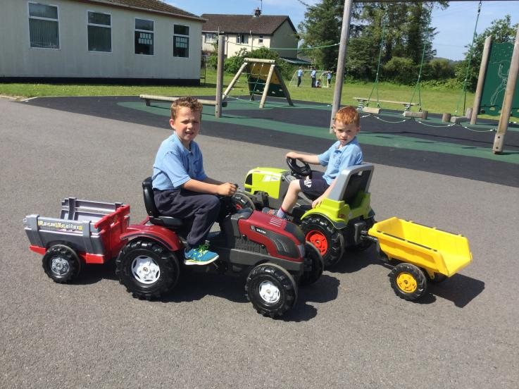
Playground fun!
RELIGIOUS EDUCATION
Religion is an important element of the school’s life. The teaching of RE, in each age group, is based on the core syllabus for Northern Ireland and is of a non-denominational character. Parents have the right to withdraw their children from RE lessons and should inform the Principal, in writing of their wishes if they want to exercise this right. The school takes great care to try to ensure that any children in this position are not made to feel excluded from the general life of the school.
Parents also have the right to withdraw their children from the act of collective worship. Again, parents wishing to exercise this right should make their wishes known to the Principal, in writing.
Every Tuesday morning the school assembly is taken by one of the local church representatives Mr. Roy Drenning, Heather Wilson and Gillian Gillespie.

SPECIAL EDUCATIONAL PROVISION
Care is taken at all times to match the curricular provision for all children to their particular stage of development and to take account of any particular difficulties or special talents which they show. Where provision beyond what can be given by the class teacher is required, every attempt will be made to provide this by the other staff in the school. In particular, the teacher with responsibility for Special Educational Needs will use her time to help those children diagnosed as being in greatest need. If necessary, the specialist services of the Board’s Special Education section will be used.

COMPLAINTS PROCEDURE
Complaints concerning the curriculum and other matters referred to in Article 33 of the Education reform (NI) Order 1989 shall be dealt with in accordance with Article 33 and Regulations subsequently made by the Department of Education.

HOMEWORK
Teachers agree that some form of homework should be given. In P1 & P2 consolidation of reading which has been done in class. We feel that parents reading stories to their children is more beneficial than “rote” reading. The children are often asked to bring in materials for a particular project or topic which leads to a lot of discussion.

In P3 the children are encouraged to read more widely than just from their reading scheme. Spellings begin from simple word building in preparation for the use of Linguistic Phonics.
During the second term the spellings are used in simple sentence construction.

In P4-P7 the homework set can be a useful follow-up to the work done in class. Otherwise it can be of an investigative nature bearing in mind that this exercise might not always be possible in some homes. As in P3 the children are encouraged to read widely outside their “Reading Scheme”.
Parents are encouraged to oversee their child’s homework but it should never be set to please parents.

With regard to the marking of homework, and with genuine concern that the time spent marking should be justifiable and not be a burden to the class teacher, it may be possible that the work may be marked by the children themselves or by a teacher, as a group exercise.
Obviously, such tasks as book reviews, for example or individual maths work must be marked personally by the teacher.

To conclude, teachers must be certain that all work to be done at home is well within the child’s capabilities and that, no matter how searching the task it makes only reasonable demands on the child’s time. As is stated in “A School Homework Policy” published by NICED, “Homework which requires excessive time or is too difficult has no place in a school whose policy is in keeping with the Guidelines”.

OUT OF SCHOOL ACTIVITIES
Usually visits are organised for classes to places of interest connected with the curriculum. The continuation of these activities will, following the introduction of new statutory requirements under the Education Reform Order, depend on the voluntary contributions of parents towards the costs.

PUPIL WELFARE
All the staff work closely together in consultation with parents to ensure the welfare of children in the school. Parents are urged to discuss any matters of concern with staff whenever they feel this is advisable. Parents are strongly advised to discuss such matters with the class teacher in the first instance. Often potential problems can be avoided if they are dealt with quickly. The Principal will be pleased to see parents to discuss any matters of concern. Parents are asked to contact school to make an appointment.

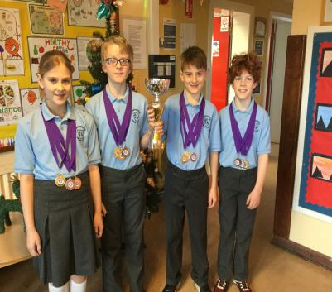
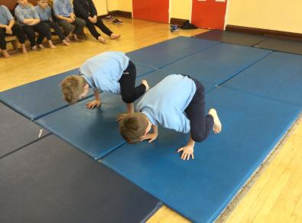
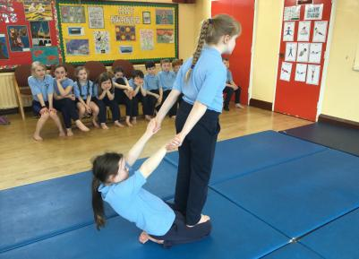


Gymnastics
Cross country Runners
Winners of the Small Schools Swimming Gala
Sport at Derrygonnelly Primary School
Hockey Awards 2018
Swimming Gala winners
Cross country runners
SCHOOL DISCIPLINE
Discipline in the school is fostered by the encouragement in each child of a sense of respect for others and their property, based on self-respect and the growth of self-discipline. The Principal and staff will consult parents in the event of any serious problems arising with a particular child. Punishment for minor lapses in behaviour usually involves the loss of personal time (such as break time) or temporarily excluded from a particular aspect of school (such as games or painting).

SCHOOL RULES
Children are expected to behave in a way which shows consideration for other people and their property. We expect them to treat both other children and adults with politeness and kindness and to have a regard for the safety for themselves and or others. The school rules are available to parents on request.

JEWELLERY
Children are discouraged from wearing jewellery to school because of the safety actor. If children have their ears pierced, then they should wear studs and not earrings. If children do come to school with inappropriate jewellery, then their teacher may require that they remove the items, or that they do not take part in activities where the teacher feels that the jewellery constitutes a safety hazard.

CLOTHING
School uniform is preferred. It is particularly important that children wear sensible footwear, whether indoors or out. The uniform is: -

Boys Grey trousers Girls Grey skirt
Navy pullover Navy jumper/cardigan
Pale blue shirt Pale blue blouse

School uniform can be bought from School Days. (Beside Toytown in Enniskillen)

PE KIT
Children are expected to be provided with suitable clothing for PE and games. All children should wear a pale blue polo shirt and navy tracksuit bottoms (no braided markings or stripes). Older children who go swimming should provide swimming costume, towel and a swimming hat if appropriate, on days when swimming should take place. All children with long hair should have it tied back.

NAMES ON CLOTHING

IF CHILDREN ARE TO ARRIVE HOME WEARING THE SAME CLOTHES IN WHICH THEY LEFT, IT IS DESIRABLE THAT ALL ITEMS SHOULD BE LABELLED WITH THE CHILD’S NAME.

HOME/SCHOOL CONTACT
The teaching staff actively encourages parental contacts with the school. The parent’s support is essential in working with the school for the child’s benefit. This school attempts to foster parental relationships in various ways such as invitations to services in the school, meetings and other events. More formal contact is made in the annual progress interviews with the class teacher. Parents may contact the Principal about any matter. However, this should, as far as is possible, be out of teaching time to keep class disruption to a minimum.

All staff may be contacted between: 8.50 am – 9.15am

Also every Monday afternoon: 3.15 pm – 4.00 pm

CHARGING AND REMISSIONS POLICY
The Board of Governors have adopted the following Charging and Remissions policy: -

A. Charging Policy
It is the policy of the Governors to charge for: -
(i) board and lodgings on residential visits

(ii) costs associated with the provision of individual tuition on a musical instrument whether inside or outside school hours unless it is provided as part of the syllabus for an approved public examination or to meet the requirements of Article 11 (1) (b) of the Order.

(iii) the cost, in cash or in kind, of ingredients or materials needed for practical subjects (such as Home Economics or CDT) where parents have indicated in advance a wish to own the finished product.

(iv) optional extra activities which take place wholly or mainly outside school hours and are additional to the education provided by the school for the purposes of preparing pupils for an approved public examination or for the purposes of meeting the statutory requirements imposed by Articles (1) (a) and (b) of the 1989 Order. Participation in any such activities is to be on the basis of parental choice and a willingness to meet such charges as are made.

B. Remission Policy
Charges will be remitted as follows: -
The charge will be remitted in the case of pupils whose parents are in receipt of income support or family credit if the education provided on a visit must otherwise be provided free, that is, the activity takes place mainly or wholly in school hours and/or is provided as part of the syllabus required in order to fulfil statutory duties in relation to the NI Curriculum or Religious Education.

C. Voluntary Contributions
In cases of activities within school time which the school cannot afford, the school will attempt to subsidise these by asking in advance for voluntary contributions from the parents of those children directly involved. Such requests for contributions will indicate the actual costs to the school and suggest this as a suitable contribution. All the children in the group will take part in the activity, whether their parents have contributed or not. In cases where contributions are such that the school (through the school fund) cannot make up the short fall, the activity will not take place and all contributions already made by the parents for the specific activity will be returned to them.

D. Breakage/Losses
The Board of Governors reserve the right to seek to recover from parents the whole or part of the cost of breakages and losses incurred as a result of a pupil’s behaviour.

INSPECTION OF DOCUMENTS
A number of documents are available for inspection at the school should parents request this. Parents wishing to inspect any of the following should give written notice to the Principal at least 3 clear school days in advance of the time they wish to see them. (This does not preclude an informal request to the Principal, who may make the documents immediately available, if this is convenient). Copies of the documents may also be made available if a week’s clear notice is given. Payment for copying will be required in advance. The documents available for inspection: -

- The Governors’ statement of the aims of the school

- Any statutory instruments, DENI circulars or administrative memoranda sent to the Principal or the governing body in relation to Part lll of the 1989 Order.

- Any published HMI Reports referring expressly to the school.

- The arrangements made by the Education Authority for the consideration and disposal of complaints under Article 33 of the 1989 Order.

- The agreed syllabus for religious education adopted by the Board.

CHANGES IN SCHOOL ARRANGEMENTS
Changes occur from time to time in the staffing and organisation of the school and parents will be informed of these by newsletter. The summaries in this booklet give the present arrangements with effect from September 2019.


Mrs Cathcart’s Achievement Cups
2017/2018


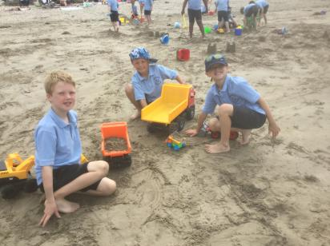
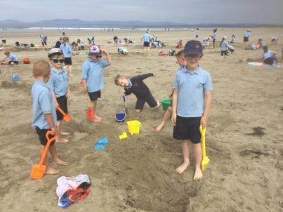
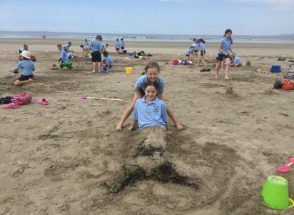
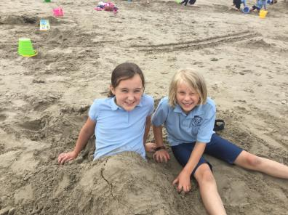
World Book Day 2018
School Trip to Rossnowlagh

